**Swimlane diagram**

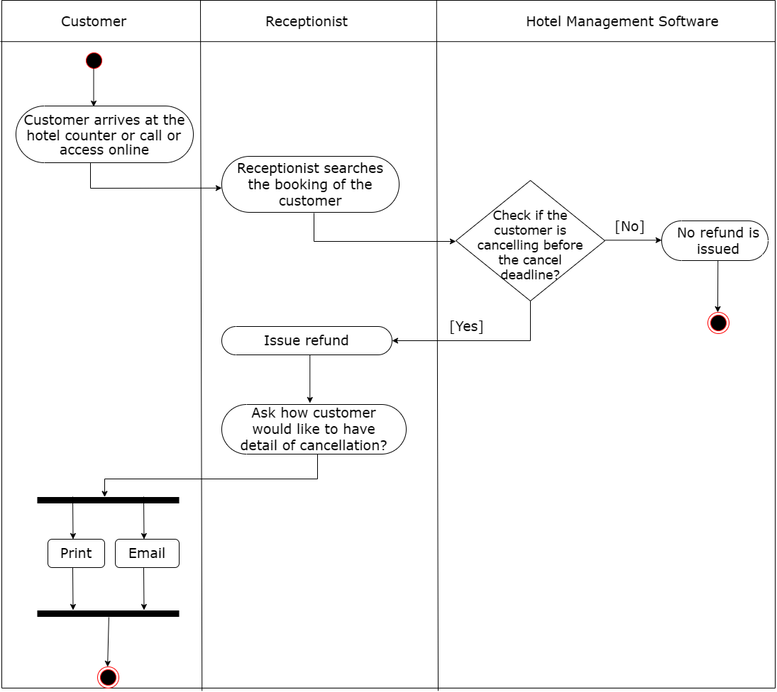

Figure 1.1 Swimlane diagram for cancel booking